**Lab 9 Report**

**LAB 9: User-Centered Design**

**Name: Hamza Mehmood**

**Class & Section: BS-SE 6TH (Evening)**

**Roll number: SP-21-110**

**Assigned Design: Utility Store App Design**

**Tasks (with report):** **Report must include screenshots and figma design link.**

In this lab, students will have the opportunity to apply their knowledge of design in a practical setting. The lab tasks include:

1. **Conduct user research to gather insights into user needs and preferences**: In this task, students will plan and conduct user research to gain a deep understanding of the target users' needs, preferences, and behaviors. They will choose appropriate research methods such as **interviews,** surveys, or **observations** to collect data from users. Students will create research protocols, recruit participants, and conduct the research sessions. They will carefully analyze and synthesize the data collected to identify patterns, trends, and user insights.

**User Research (Interviews):**

**Objective:** To explore the shopping preferences of young professionals using the utility store mobile app.

**Method:**

**Participant Recruitment:**

Recruited 10 young professionals aged between 18-25 who use mobile apps for grocery shopping.

Ensure a balance of gender, occupation, and shopping frequency.

**Interview Guide:**

Questions include:

“How often do you use our utility store app for shopping?”

“What features do you frequently use, and why?”

“Can you describe a time when the app made your shopping easier or harder?”

“What improvements would you like to see in the app?”

**Data Analysis:**

Identify that most participants appreciate the app’s **quick checkout** feature but struggle with the **search functionality**.

**User Research (Observations):**

**Objective:** To observe the app’s usability when users are multitasking.

**Method:**

**Contextual Inquiry:**

Observe users at a cafe during lunch hours as they order groceries for the week.

Note their interactions with the app amidst distractions.

**Usability Testing:**

Users are asked to find and apply a coupon for their purchase.

Observers note that several users fail to locate the coupon section.

**Shadowing:**

Follow a user named Hamza as he uses the app while commuting on the train.

Notice that she uses the **favorites** feature to quickly add items to her cart but gets frustrated with occasional app crashes.

**Data Synthesis:**

Compile observations and find that users needs a **stable app experience** during commutes.

**2)** **Generate design ideas and create prototypes based on user research findings:**

Based on the insights gathered from user research, students will generate design

ideas and concepts. They will brainstorm potential solutions and explore different

approaches to address user needs and preferences. Students will then create

prototypes to visualize and communicate their design ideas.Do attach screenshots with respective Link

**Version 1:**

[**https://www.figma.com/file/jdeaC37OXoUNIxgOYe48SP/Hamza-grocery-store?type=design&node-id=0%3A1&mode=design&t=E9s96HStUEXC8t9d-1**](https://www.figma.com/file/jdeaC37OXoUNIxgOYe48SP/Hamza-grocery-store?type=design&node-id=0%3A1&mode=design&t=E9s96HStUEXC8t9d-1)

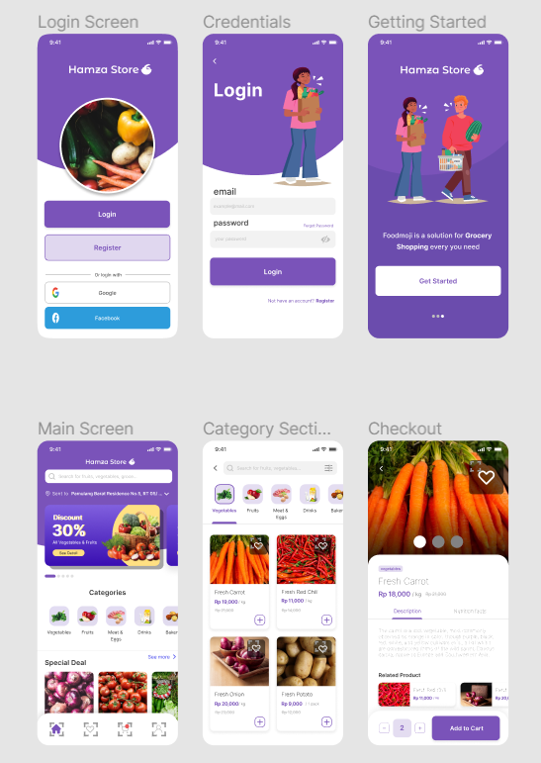

Page **1** of **2**

**Evaluating Recommendations:**

* The Buttons are too big.
* Important Icons should be there.
* Login Text and Forgot Password is not in Position.
* Slide Button should be in Center.
* Item text is too thin.
* Heart icon is too big.

**4) Iterate and refine the design based on user feedback:** Based on the feedback received from users during the testing phase, students will analyze the data and identify areas for improvement. They will iteratively refine their design by making necessary adjustments, addressing usability issues, and incorporating user suggestions. Students will consider the feedback received and prioritize design changes that align with user needs and preferences. They will update their prototypes accordingly and prepare for subsequent testing cycles.

Do attach screenshots with respective Link

**Version 2:** [**https://www.figma.com/file/jdeaC37OXoUNIxgOYe48SP/Hamza-grocery-store?type=design&node-id=0%3A1&mode=design&t=E9s96HStUEXC8t9d-1**](https://www.figma.com/file/jdeaC37OXoUNIxgOYe48SP/Hamza-grocery-store?type=design&node-id=0%3A1&mode=design&t=E9s96HStUEXC8t9d-1)

